MONARCHY IN EUROPE 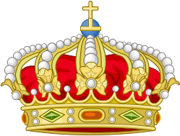
WORKSHEET

Today you are going to learn about MONARCHY. The topics include: some basic information about the forms of government in Europe (monarchy vs. republic) and the role of Queen Elizabeth II as the current head of the British monarchy.

Warm-up
Imagine you are the King/Queen for a day. What would you do? Where would you go? Who would you meet? Plan your ideal day.
- First ...

- Then ....

- Afterwards ...

- Finally ...

Before we start, let’s revise a few words and phrases that you may find useful:

ENGLISH | POLISH
reign
Her Majesty
Commonwealth of Nations
abdicate
inherit
heir to the throne
knowledgeable
high priority
royal family
appoint
embody
sovereignty
take on responsibilities
deliver a radio broadcast
rage a war
provide comfort
mourn the loss
tremendous
preside (over)
realm
relevant
do away (with)
curtsy
walkabout
mingle (with)
frugal
recover (from)
insist

TASK 1
Mark the countries on the map. What do they all have in common?

- Andorra
- Belgium
- Denmark
- Liechtenstein
- Luxembourg
- Monaco
- The Netherlands
- Norway
- Spain
- Sweden
- The United Kingdom
- The Vatican City
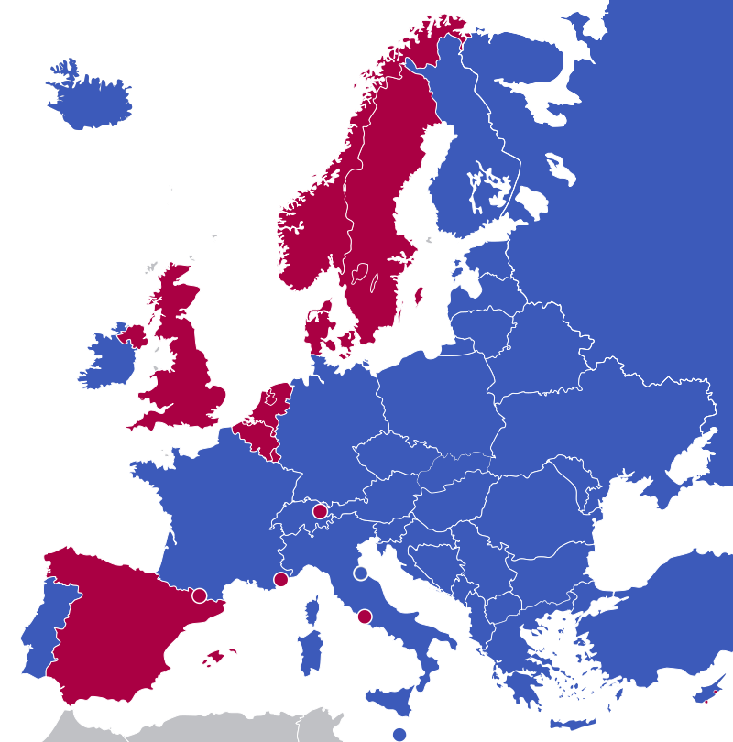

TASK 2
The king or queen and all the members of their family constitute the royal family of a country.
Answer the following questions about the British Royal Family.

- What is the surname of the British Royal Family?

- How many children has Queen Elizabeth II got?

- Who is currently first/second/third in line to the throne?

- Which member of the Royal Family died on 31st August 1997?

- What is Prince William’s wife’s official title?

- How are William and Camilla related?

- How are Kate and Harry related?
- How are Elizabeth II and Charlotte related?

TASK 3
Watch the video about Queen Elizabeth II.

- PART I
Decide if the statements are true or false.

 | TRUE | FALSE
- Queen Elizabeth II is nearly 90 years old.
2. It was obvious when Elizabeth was born that one day she would be queen.
3. She has been the Queen of the Commonwealth of Nations for 65 years now.
4. She’s the eldest daughter of King George V.
5. At the age of 14 she delivered a radio broadcast to encourage children to volunteer.
6. She was coronated after her father abdicated the throne.

.
- PART II
Answer the questions.

- Was Elizabeth in charge of the entire Commonwealth after her coronation?

- What are the Queen’s responsibilities?

- What has Elizabeth II done to modernize the royal family?

SUMMARY
Complete the sentences with your own thoughts.

- One interesting thing that I learnt in this lesson was that ...

- One thing that surprised me was that ...

